**PATUAKHALI SCIENCE AND TECHNOLOGY UNIVERSITY**

**COURSE CODE EEE-212**

**Electrical Technology Sessional**

**SUBMITTED TO:**

### **Md. Naimur Rahman Professor Department of Electrical and Electronics Engineering Faculty of Computer Science and Engineering**

**SUBMITTED BY:**

**Md. Sadman Kabir Bhuiyan**ID: **2102020**,   
Registration No: **10147**Faculty of Computer Science and Engineering

**Md. Sharafat Karim**ID: **2102024**,   
Registration No: **10151**Faculty of Computer Science and Engineering

Date of submission:Project title: **Metro Recharge Point**

**Metro Recharge Point**

## ****Description****

Metro rail card's self recharging utility with mobile banking ability. Where users can scan their card and access their accounts with simple clicks.

## Brief History

In general in a metro rail system, whenever a user wants to travel, he has to go to the ticket counter and form a query, in order to collect the ticket, which makes the whole entire process more time-consuming. To solve this issue, we can implement a backend server for database and API, and use our system as frontend.

## Objectives

1. Developing an Arduino-based system with RFID readers for identifying metro cards.
2. Integrate a secure mobile banking platform for users to recharge their metro cards on 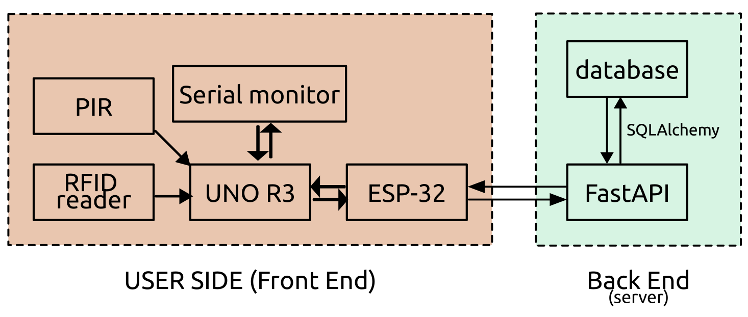the go. Where user can use mobile banking/ any specific hardware to recharge cards.
3. Implement a backend system to track user balances, recharge, and discharge transactions using **FastAPI** and **SQLAlchemy**.
4. Ensure seamless communication between hardware components (Arduino, RFID reader) and backend services via HTTP requests.
5. Auto check balance on card punch, and LED color to indicateb balance.

## Scope

* **Hardware Integration**: Utilize components such as RFID Readers, ESP32, PIR sensors, and buzzers for card detection and system feedback.
* **Backend Development**: Develop a FastAPI-based RESTful API to handle user balance management, including recharge, discharge, and user creation functionalities.
* **Mobile Banking Integration**: Enable secure mobile banking transactions for recharging metro cards.
* **Real-time Data Processing**: Ensure real-time updates to user balances via cloud-hosted services. It can also be deployed on a local server.

## Benefits

* **User Convenience**: Quick and easy metro card recharges from any location using mobile banking or specific machines. Further systems can be easily developed for using the same backend. For example, bus ticket system.
* **Real-time Updates**: Users can track balances and manage their metro cards through a user-friendly interface. Or, they can also use an interface hosted on web to quickly access. Besides, there can be admin panels and administrations control access, in order to debug things out.
* **Scalability**: Designed to handle large volumes of users and transactions efficiently. Besides, it can be integrated into other systems, as well as handling multiple purposes.
* **Data Analyze:** Backend servers can also implement anonymous data collection. Which will be a great help for future crowd controlling and preparing more efficient schedule for the entire train system.

## Backend Server

* **Python FastAPI**
* **SQLAlchemy**
* **SQLite/MySQL** (for database)
* **Python**
* **Uvicorn** (for ASGI server)
* **Pydantic** (for data validation)
* **HTTP/HTTPS**

## Frontend Budget

|  |  |
| --- | --- |
| **Equipments Name** | **Approx. Price** |
| PIR (Passive infrared sensor) | 110 |
| Arduino UNO R3 SMD | 574 |
| Cable | 55 |
| Breadboard | 150 |
| Buzzer | 15 |
| RFID Reader | 195 |
| RFID Cards | 70 |
| Resistor | 30 |
| ESP 32 | 470 |
| LED | 5 |
| Matrix keyboard | 75 |
| LCD display | 273 |

## **Estimated Timeline**

* **Phase 1**: Hardware integration and system setup (2 weeks)
* **Phase 2**: Backend development and database integration (3 weeks)
* **Phase 3**: Mobile banking integration and testing (3 weeks)
* **Phase 4**: Final testing, deployment, and user feedback (2 weeks)